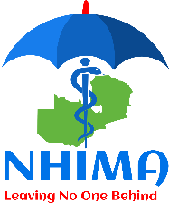

PUBLIC NOTICE

Removal of Buy-Back Option from the National Health Insurance Scheme

Lusaka Wednesday, January 03, 2024.
The National Health Insurance Scheme (NHIS) was established in pursuant to section 4 of the National Health Insurance (NHI) Act No. 2 of 2018, supported by Statutory Instrument No. 63 of 2019. The National Health Insurance Management Authority (NHIMA) was established to among other things; manage the NHIS, that insures all Zambian citizens and registered residents against the costs of Health care.

In the year 2020, NHIMA introduced a Buy-Back option to enhance registration and service utilization. This Buy-Back option allows members to pay for four (4) months’ worth of contributions at once and access services immediately, without any waiting period.

However, starting from 1st January 2024, NHIMA withdrew the Buy-Back option. This entails that only those who consistently make contributions for at least four (4) months would be allowed to access services under NHIS. Citizen and established residents registering after January 1, 2024, will need to contribute for four (4) consistent months before accessing NHIMA services. This decision is aimed at ensuring that all registered members are compliant and that only those who are current with their contributions can access services.

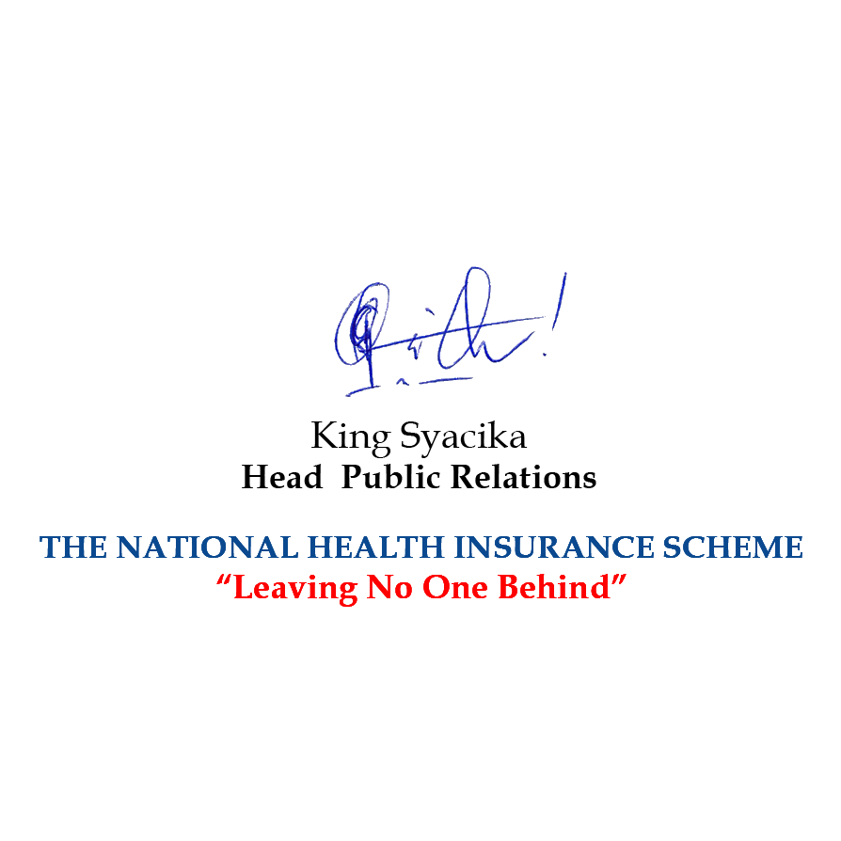
Remember, by contributing regularly, you will ensure the sustainability of the National Health Insurance Scheme and guarantee access to high-quality healthcare services when you need them.

